TCWPA Battlefield Assessment  Union Station  NARRATIVE  On November 1, 1864 a patrol of the 10th Missouri Cavalry Regiment (Union) was dispatched from Memphis to scout for enemy forces in the area of the Union Station depot. After driving 3 Confederate scouts through Union Station, a detachment was left behind to guard the depot while the remainder of the patrol proceeded toward Somerville. About 11:30 a “band or company of Confederates attacked the depot capturing the detached Union forces and taking 23 prisoners, arms, equipment and horses. The Confederates escaped before the returning Union patrol could engage them.  HISTORICAL THEMES  Controlling Resources  EXPLANATION OF ATTACHMENTS/VIDEO:  Maps and article  LINKS FOR FURTHER INFORMATION:  N/A | 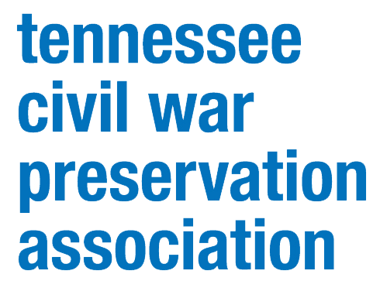  COUNTY:  Shelby  DATE:  11/1/1864  GEO COORDINATES:  35.221533° N,  89.908250° W  PRESERVATION OPPORTUNITY INDEX:  LOW  CONFEDERATE UNITS:  UNION UNITS:  10th Missouri Cavalry  3rd Iowa Cavalry

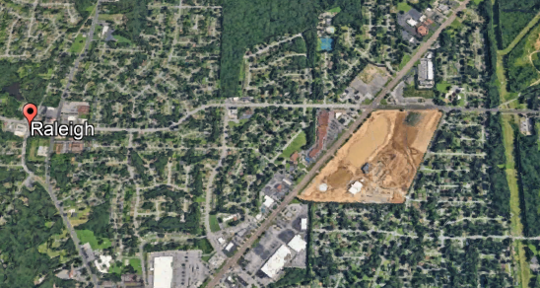
Site of Union Station skirmish
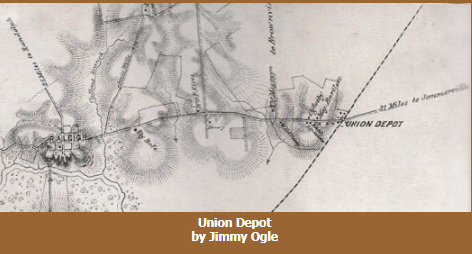

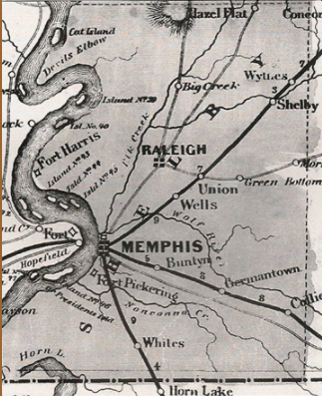

On the 1857 map of Shelby County, Union Depot appears about seven miles northeast of Raleigh on the Memphis & Ohio Railroad line, at the intersection of Stage Road.
The Memphis & Ohio Railroad (M&O, also known as the Memphis, Clarksville & Louisville railroad – MC&L) was charted in 1852 and opened in 1859. The M&O extended through Arlington, Brownsville, Humboldt, and Milan in West Tennessee up through north middle Tennessee (Clarksville) all the way to Louisville (Kentucky), and eventually Cincinnati (Ohio). Its line was heavily damaged during the Civil War, and in 1865, the MC&L went into receivership and was bought by the Louisville & Nashville Railroad Company (L&N).
The named Union Depot is derived from the “Union occupation” during the Civil War to protect its interests in keeping troop and supply movement lines open from the north to the steamboat port of Memphis. The Union had taken occupation of the Memphis on June 6, 1862, because its importance as a rail and river center, and eventually a hospital center for wounded soldiers. Memphis became instrumental in Gen. Sherman’s “March To The Sea” and Gen. Grant’s planning of the Battle of Vicksburg.
Rural Heritage Trust - Union Depot

LEGEND OF TERMS:

Historical themes: Topics and subject matter that characterize the battlefield including Control of Tennessee’s Resources, Crucible for Leadership, Guerilla Warfare, Transformation in Warfare, Enslaved People, and Influence on Campaign. Sites are identified that exhibit themes at moderate to high levels, and some sites may contain one or more Historical Themes.

Preservation Opportunity Index (POI): A rating assigned for each battlefield to indicate relative opportunity and potential for successful site preservation. The Index is generated by a model that evaluates ratings assigned for site significance, condition, risk of loss, protection potential, and opportunities for interpretation. Based upon the POI values for each region in Tennessee (West, Middle, East), sites are indicated as having High, Medium, or Low opportunity.

Geo Coordinates: General/central location of the battlefield area per latitude and longitude coordinates utilized in Google Earth

DO YOU HAVE INFORMATION ON A BATTLE SITE?

Please email us at info@tcwpa.org and we will reach out to you soon. If you have copies of documents or photos to share, you can include those. If you want to discuss by phone, we will schedule that too.

HELP US COLLECT INFORMATION TO PRESERVE THESE BATTLEFIELDS

TCWPA's Statewide Preservation Plan team captains are recruiting volunteers to help gather information about many of the lesser-known sites with hopes of verifying the condition of each site and identifying opportunities for preservation and interpretation.
If you are interested in helping, please contact TCWPA at info@tcwpa.org .

TCWPA will not publish nor release any confidential information, or the name of the contributor, unless you request to be recognized.
Thank you!
